Chapter 16, Problem 24.

The switch in the circuit of Fig. 16.47 has been closed for a long time but is opened at t = 0. Determine i(t) for t > 0.

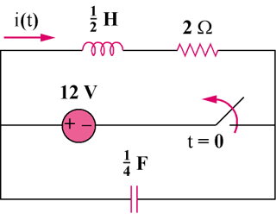

Figure 16.47
For Prob. 16.24.

